Going into more mathematical stuff

* Sigma
* 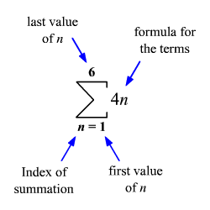

|  |  |  |  |
| --- | --- | --- | --- |
| N | N sigma n = 1 | First differences | Second Differeces |
| 1 | 1 |  |  |
| 2 | 3 | 2 | 1 |
| 3 | 6 | 3 | 1 |
| 4 | 10 | 4 | 1 |
| 5 | 15 | 5 |  |

* Follows formula n(n+1)/2
  + (N2 + n)/2
* Only possible to have natural numbers with sigma(1,2,3,4,5,6)
* an! = nth differences
* a(2)! = 1
* a = 1/2